

**Request for Quotation**

|  |  |
| --- | --- |
| **Request for Quotation (RFQ)** | **Caretaker / Management Services | River Drive Caravan Park / Camp Ground** |
|  |  |
| **Closing Date and Time** | 23/06/2025 at 17.00pm AEST |

**Privacy Notice:**

Cassowary Coast Regional Council is collecting your personal information in accordance with the *Information Privacy Act 2009 (Qld),* and other applicable laws. Your information is being collected for the purpose of processing your application and/or responding to your enquiry. It may be used by an authorised Council officers and disclosed to other agencies or third parties where required or permitted by law. Providing this information in voluntary; however, if you do not supply the requested information, Council may be unable to provide the requested service. You have the right to access and amend your personal information held by Council, subject to legal constraints. For more information, please view Council’s Privacy Policy on Council’s website

|  |
| --- |
| **REQUEST FOR QUOTATION** |
| **Project Name:** |
| River Drive Caravan Park | On-site Caretaker / Management Services |
| **Location / Site Address:** |
| 7 River Avenue, Mighell QLD 4860 |
| **Introduction:** |
| Cassowary Coast Regional Council (CCRC) is requesting quotations for Caretaker / Management Services at the River Drive Caravan Park. The proposed term is from 1 July 2025 to 31 January 2026 with potential to extend thereafter. The landscaped park comprises a total of 49 powered sites, undercover camp kitchen, Office/Caretaker accommodation (2-bedroom, 1-bathroom with reception / kiosk area), 2 x amenities blocks and coin operated laundry. The Caravan Park will trade from 1 July to 30 November 2025 (Trading Period). And will be closed from 1 December 2025 (Closure Period). The scope for the Caretaker/ Management Services varies between the trading period and the closure period (see Technical Specification).  The successful candidate will be representing the CCRC, as such, must act in accordance with CCRC organisational values and code of conduct.  **Applicants must complete and respond to the Price Schedule, Selection criteria and Compliance Criteria to be considered.** |
| **Background:** |
| CCRC is seeking to engage a caretaker/manager to operate the River Drive Caravan Park of behalf of CCRC for a short, fixed term period. CCRC owns the River Drive Caravan Park located 7 Mighell Avenue, Mighell adjacent to the Johnstone River. This family-friendly park offers 49 powered sites. The park includes two amenities blocks with modern facilities, including hot showers and clean restrooms. The park also features an undercover camp kitchen with views over the South-Johnstone River and a coin-operated laundry for use by guests. |
| **Objectives:** |
| To locate a suitable qualified person or entity to properly manage and caretake the caravan park to meet current regulations and expectations of Council and the community and to provide an enjoyable visitor experience for all guests of the park; and provide maintenance and security during the closure (wet season) period. |
| **Workplace Health and Safety:** |
| Applicants are required to have a current Construction Induction (White Card) and Blue Card (or ability to obtain one within 14 days of this submission) and complete a CCRC induction prior to commencing. These are mandatory requirement for the Caretaker role. |
| **Briefing / Site Inspections:** |
| Not mandatory. Available on request within select business hours of Monday 16 – Friday 20 June 2025 |

|  |  |  |  |  |  |  |  |  |  |  |  |  |  |  |  |  |  |  |
| --- | --- | --- | --- | --- | --- | --- | --- | --- | --- | --- | --- | --- | --- | --- | --- | --- | --- | --- |
| **Schedule of Prices – Quotation Lump Sum**  **Program of Work / Timing Requirements:**  **Quotation Validity Period:**  **Contract Period: 7 Months**  **Quotation Lump Sum**   |  |  |  | | --- | --- | --- | | **1 July to 30 November 2025 (Trading Period)** | | | | **SUM PER MONTH (FLAT FEE)**  **(EXC GST)** | **GST (IF APPLICABLE)** | **SUM PER MONTH**  **(INC GST)** | |  |  |  |  |  |  |  | | --- | --- | --- | | **1 December to 31 January 2026 (Closure Period)** | | | | **SUM PER MONTH (FLAT FEE)**  **(EXC GST)** | **GST (IF APPLICABLE)** | **SUM PER MONTH**  **(INC GST)** | |  |  |  |   **NOTE:**   * The maximum allowable price is $1,150pw + GST (Trading Period) and $575pw + GST (Closure Period) * Caretaker Residence is available at no cost   APPLICANT NAME(S):  SIGNATURE:  DATE:  Pay Period – Monthly within 30 days of invoice receipt. |

|  |
| --- |
| **Technical Specification** |
| **Preliminaries:**  This Specification has been prepared to clarify the statement of works and duties to be performed for this contract.  **Caretakers Key Obligations and Duties (1 July 2025 to 30 November 2025 – Trading Period):**   1. Take bookings and allocate sites using Councils cloud-based booking system – Newbook. 2. Collect and receipt all fees and deposits as per CCRC Fees and Charges Schedule. All monies received should be receipted using a CCRC supplied EFTPOS machine. **No cash is accepted.** NOTE: Cash from the coin operated laundry machines is to be deposited at the CBA using Councils deposit slips within 7 days of the end of each month. Exception with extended power outages an alternate process is to be used to collect payment and receipting. 3. Provide relevant data and reports to CCRC officers when required. Computer literacy is essential. 4. Provide a high level of customer service to visitors and occupiers alike. 5. Daily cleaning of on-site amenity blocks and facilities, plus reactive clean as required due to any incidents that may occur, including camp kitchen. Carry out a monthly ‘deep clean’ of amenities block including a power wash and disinfection of all hard surfaces. Maintain an onsite cleaning register visible to guests. Cleaning consumables are provided by Council, on a stores ordering basis. 6. Provide change for the coin operated laundry, as required. 7. Undertake mowing, weed management and gardening across the whole site to a standard as designated by Council Officers. Mowing equipment (ride-on mower, push mower and whipper snipper) supplied by CCRC. Any other landscaping equipment required aside that which is already supplied, must be requested through Council. Fuel, oil and other consumables for landscape and garden maintenance can be reimbursed by Council on the provision of receipts and an invoice. 8. Collect and dispose of palm fronds and tree litter from around the site ‘as required’. 9. Provide a ‘value for money’ approach with repairs and maintenance issues across the site. Applicants with a knowledge of facility maintenance will be preferred, i.e. there is an expectation that the Caretaker will undertake minor maintenance works, such as tap washer change, garden irrigation leaks, changing low level light bulbs. Subject to Council’s assessment, reimbursement of expenditure will be provided on the provision of receipts and an invoice. 10. Report any incidents of a serious nature to CCRC’s Principal Facilities Operations or Manager Facilities and Leasing or Delegate within 24 hours. Maintain an incident book on-site. 11. Provide monthly report to the CCRC’s Principal Facilities Operations or Manager Facilities and Leasing or Delegate regarding visitor numbers, occupancy and revenue in a digital format to be approved by CCRC. 12. Use best endeavours to ensure the safety of all persons attending the site. The Caretaker will duly and punctually comply with and observe all statutes and all orders, ordinances, regulations, local-laws and permits relating to the operations of the Caravan Park and the caretakers use or occupation of the park. 13. Work with CCRC Officers to maximise the return / profit of the site. 14. Take all necessary steps to ensure that persons occupying the caravan park do so in an orderly and law-abiding manner and without nuisance or annoyance to other occupiers and in accordance with the park rules. 15. Carry out all other obligations and duties as outlined in the Caretaker Agreement. 16. Act in accordance with CCRC organisational values and Code of Conduct at all times. 17. CCRC may determine or consider a request from the Caretaker to temporarily close the park outside of tourist season for such period and on such terms as CCRC considers appropriate. If the Caretaker does not have a person residing on-site or if the park is temporarily closed, the Caretaker must erect a sign at the entrance to the park of the closure and manage accordingly.   **Caretakers Key Obligations and Duties (1 December 2025 to 31 January 2026 – Closure Period):**   1. Undertake mowing, weed management and gardening across the whole site to a standard as designated by Council Officers. Mowing equipment (ride-on mower, push mower and whipper snipper) to be supplied by CCRC. Any other equipment together with all fuel, oil and other consumables is to be provided by the Caretaker at its own cost. 2. Carry out weekly inspections and ‘spot’ cleaning of the amenities blocks during the closure period 1 December 2025 to 31 January 2026 3. Between 20 January 2026 to 31 January 2026 the caretaker is to carry out a deep clean of all amenity blocks and the camp kitchen. This includes a pressure wash and disinfection of all hard surfaces.   **Caretaker Residence / Reception:**  The Caretaker residence is available for occupation by the successful applicant. All related operating utility costs are paid by Council. The applicant will have to maintain the premises and hand back the property at the equivalent standard as on the commencement date. The value of this should be considered in the applicant’s fee proposal.  **The applicant is to take the following documents into consideration as part of their response:**   * **Attachment 1 Caretaker Agreement** * **Attachment 2 Cassowary Coast Regional Council Code of Conduct** * **Attachment 3 Site Plan**   **Deliverables**  The term of the contract is from the 1/07/2025 (or ‘as close to’) to 31/01/2026.  **Handback**  The site is to be handed back to the owner in the same condition as it was handed to the Caretaker. All receipts, accounts, booking details and any other IP is to be handed over to the CCRC prior to the termination date. |

|  |  |  |  |  |  |  |  |  |  |  |  |  |  |  |  |
| --- | --- | --- | --- | --- | --- | --- | --- | --- | --- | --- | --- | --- | --- | --- | --- |
| **Selection Criteria & Weighting**   |  |  |  | | --- | --- | --- | | **Title** | **Description** | **Weighting** | | Value for Money | Assessed on submitted monthly charges (Lump sum price) | 40% | | Relevant Experience and referees | Provide a resume detailing relevant industry experience as a caretaker or park manager in the industry. List key duties undertaken size of the park and two referees of the principal or property owner. Other Hospitality / customer service experience would also be considered.  A demonstrated track record of providing a ‘value for money’ approach with repairs and maintenance issues across the site. | 40% | | Commencement date | Be able to commence works and mobilise to site by 1 July 2025 (or ‘as close to’ – please specify) | 10% | | Local Content | Local resident or intention to relocate to Cassowary Coast Region; how local businesses/ tourism economy may benefit with success of submission | 10% |   **Mandatory Criteria**  Please provide evidence of the following, or have the ability to provide within 14 days from the submission date:   * Police check (satisfactory to Council requirements) * White card * Blue Card * Current and valid Australian Driver’s license * Current Australian ABN and or ACN * CCRC Contractor Induction   I / we ___________________________________ acknowledge that if the above cannot be presented to CCRC within 14 days from the closing date (23 June 2025) the submission will be considered non-compliant and any agreement can be terminated immediately by CCRC:  Signature(s): __________________________________  Name(s): __________________________________  Date: __________________________________  **Closing Date and Time for Quotes:** |
| Monday 23 June 2025 at 5.00 pm |

|  |  |  |  |  |  |  |
| --- | --- | --- | --- | --- | --- | --- |
| **Lodgement of Quotations:** | | | | | | |
| The format for Submissions must be in Microsoft Office (Word) or Adobe PDF.  Please ensure files are clearly named with the RFQ name and brief description of the document.  **Please submit your quotation by email to: Peter McBride |** [**peter.mcbride@ccrc.qld.gov.au**](mailto:peter.mcbride@ccrc.qld.gov.au) | | | | | | |
|  | | | | | | |
| **Contact Officer Name:** | | Peter McBride | | | | |
| **Position:** | | Principal Facility Operations | | | | |
| **Branch / Department:** | | Infrastructure Services | | | | |
|  | | | | | | |
| **Phone:** | 1300 763 903 | | | **Mobile:** | 0436 945 168 | |
|  | | | | | | |
| CCRC Use Only: | | | | | | |
| BUDGET AVAILABLE:  $ | | | ACCOUNT CODE: | | |  |
| PROJECT MANAGER APPROVAL:  Signature:  ______________________________ | | | MANAGER APPROVAL:  Signature:  ____________________________ | | | DIRECTOR APPROVAL:  Signature:  __________________________________ |

**ATTACHMENT 1 – CARETAKERS AGREEMENT**

[Standard Caretaker Agreement - River Drive - Template.docx](https://cassowarycoast-my.sharepoint.com/:w:/g/personal/peter_mcbride_ccrc_qld_gov_au/EdmNGt9P-6hDr4y-W8NpghsBpaVipfoY5GAp1Z8dPm-lkg?e=ulyEBB)

**ATTACHMENT 2 – CODE OF CONDUCT**

[Contractor Code of Conduct 20240926](https://www.cassowarycoast.qld.gov.au/downloads/file/4803/ccrc-contractor-code-of-conduct)

**ATTACHMENT 3 – SITE PLAN AND MUD MAP (SEE BELOW)**

**ATTACHMENT 3 – SITE PLAN**

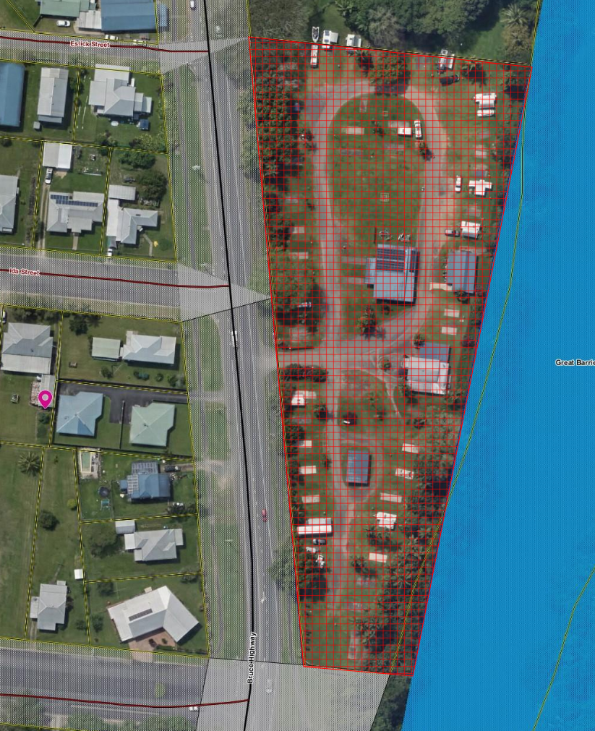

**Mud Map:**

